Chapter 19, Problem 65.

What is the y parameter presentation of the circuit in Fig.19.112?

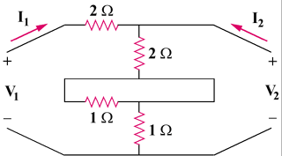

Figure 19.112
For Prob. 19.65.

